Lab 5: Adversarial Search: Minimax & Alpha-Beta Pruning

Course:
Artificial Intelligence Lab

Submitted by:
Aman Khawar

Roll Number:
SU-92-BSSEM-S25-019

Section:
BSSE-4A

Submitted to:
Rasikh Ali

Task 1:
Manual Minimax:
Objective:
The objective of this task is to solve a game tree manually using the Minimax algorithm.
Introduction:
Minimax is an adversarial search algorithm used in games. It has two types of nodes: MAX and MIN. MAX selects the highest value, while MIN selects the lowest value. The values are calculated from the leaf nodes toward the root.
Given Leaf Values:
The given scores are:
[3, 5, 2, 9, 0, 7]
To make a complete binary tree, two zero values are added:
[3, 5, 2, 9, 0, 7, 0, 0]
Manually Trace:
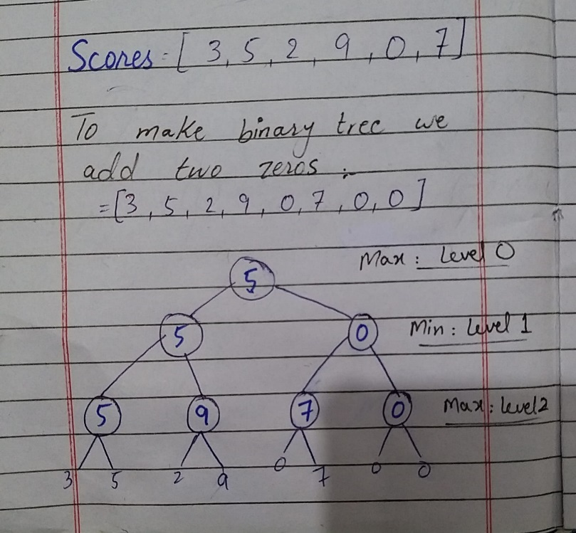

Result:
The optimal value at the root is 5. MAX should choose node A because it gives a value of 5, while node B gives a value of 0.
Task 2:
Leaf Evaluation Counter:
Objective:
To compare the number of leaf nodes evaluated by Minimax and Alpha-Beta Pruning.
Implementation:
I added a counter to both algorithms. The counter increases whenever a leaf node is evaluated. Both algorithms use the same game tree.
Manually Trace:
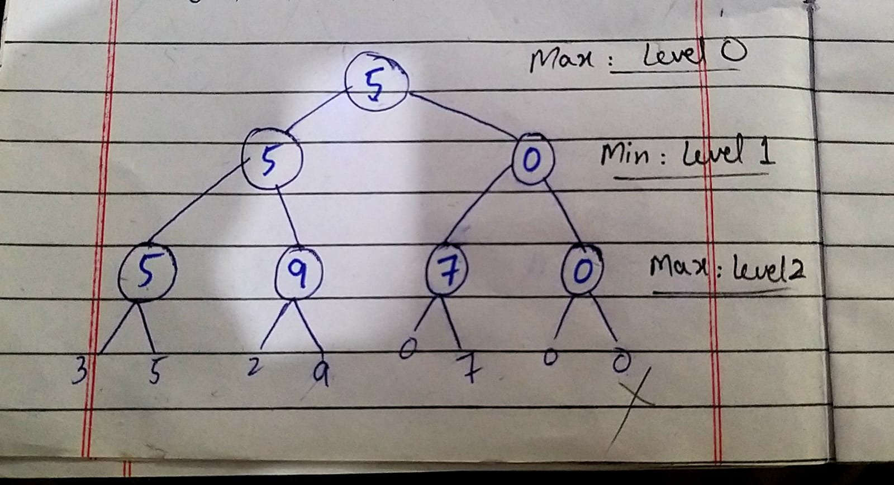
Results:
Algorithms | Optimal value | Leaves Evaluated
Minimax | 5 | 8
Alpha beta pruning | 5 | 7

Conclusion:
Both algorithms return the same optimal value of 5. However, Alpha-Beta Pruning evaluates fewer leaf nodes because it skips branches that cannot affect the final result.
Task 3:
Branch Ordering and Pruning:
Objective:
To observe how changing the branch order affects Alpha-Beta Pruning.
Implementation:
I changed the order of the branches and ran the Alpha-Beta algorithm again. The same leaf values were used.
Conclusion:
Changing the branch order does not change the optimal Minimax value. However, it affects the number of leaves evaluated by Alpha-Beta Pruning. In the reordered tree, one leaf was pruned, making the search more efficient.

